**Abstract**

We often see that Pakistanis (the people of Pakistan) have trouble accessing correct, relevant and to the point information for legal concerns. Our people are not in knowledge of their country's legal rights. In most cases, we see in everyday life that people find it very tedious to go to court and deal with different lawyers, or that lawyers do not have enough resources to reach out to those who require their services.

One solution is to create a virtual web application platform where people may contact lawyers to discuss concerns, schedule appointments, get legal advice, and learn about their rights. Presently, Our app aims to overcome the important gap between a lawyer and his client. People can publish their legal issues on the online portal Link-Law.pk, and legal professionals will contact them. In addition to sharing experiences and conversing with possible clients, attorneys can market their profiles.

# Introduction

We witness that Pakistanis often need legal services on a daily base, but to get the services of a lawyer becomes a big challenge to handle legal proceedings, know your rights, and ask questions and get help, especially for those living in villages and backward areas. To counter these issues, we are providing an idea of a brand-new website only for Pakistanis called Link-Law.pk. As a digital platform for those in need of legal help and reaching lawyers, this platform hopes to raise legal know how of the public and improve accessibility to their rights.

We hope to provide, cases reviews, and a platform for lawyers too. People will get easy legal advice and then they will make informed decisions and defend their rights thanks to the availability of our platform. In the race to improve justice in society, this brief introduction sets new goals for other projects and provides inspiration to new ideas.

The website will be offering a prediction tool that will be based on machine learning in addition to the already given features of our website Link-Law.pk. This new and innovative feature of a Machine trained model with the main idea of our legal platform will predict probable legal results based on the situation of the given case at hand. This tool will give our users more facilitates and allow their ability to access justice and make better decisions along the way.

Addressing Legal Challenges

Link-Law.pk will serve as a comprehensive platform for our users, where individuals can access a broad spectrum range of legal resources, guidance, consultancy services and many more. With the complexity of legal matters increasing, navigating through legal processes can often become more difficult. Our website Link-Law.pk wishes to simplify this process totally by providing our users with easy access to reliable legal information, consultancy from experienced legal professionals out in the market, and a platform to connect with lawyers and attorneys altogether.

At the heart of our project Link-Law.pk is the commitment to empower all the users we have, by providing them with the knowledge, resources, and support they need to address their legal challenges effectively in our daily lives in Pakistan. We are under the impression, and it is our understanding of basic legal concepts, seeking advice on specific legal issues that we are facing, or finding the right legal representation for our particular issue, The platform that we will be developing named the Link-Law.pk offers a user-friendly and accessible platform to meet these mentioned needs to our clients and lawyers with accuracy.

## Key Features and Functionality

The platform that we are going to develop which will be called Link-Law.pk provides a range of features designed to enhance our user experience and facilitate all of our users with efficient interaction between them and legal professionals present on our developed platform. These include:

Comprehensive Legal Information:

This website that we are going to develop is going to be a repository of basic Pakistani laws and legal concepts to educate the people of Pakistan and also all of our users and provide them with a foundation of legal knowledge that is conducted in our country.

Consultancy Services:

We will be offering a platform where our users can seek expert legal advice and consultancy from a diverse pool of qualified lawyers and attorneys from leading institutions in Pakistan that will be working as a representative of our platform.

Appointment Scheduling:

A convenient system for our users to schedule appointments with the lawyers on platform and attorneys based on their availability and expertise and also their interests.

Interactive Platform:

A dynamic platform where the users on our platform can engage with legal professionals, exchange contact information with them, advertise their legal problems, and receive personalized assistance in return to their queries.

Machine Learning-based Prediction Features:

One of the advanced features that will be powered by machine learning technology to provide our platform users with insights into potential legal consequences based on their specific circumstances that they will face.

## Objectives

* **Enhance Access to Legal Information**
* **Facilitate Consultancy Services**
* **Streamline Appointment Scheduling**
* **Enable Interactive Communication**

## Problem statement

"In our country Pakistan, access to reliable legal advice and services can be challenging for individuals who are facing legal issues in our social lives. As we have limited access to legal information in our daily life, we often do face difficulty in finding a well-qualified legal professional, and the complexity of legal processes often stop our individuals from effectively addressing the legal challenges that they face. This lack of accessibility to legal assistance in our surroundings contributes majorly to disparities in accessing justice and resolving legal issues efficiently in time for the individuals of our country. Therefore, considering all these problems that we are currently facing there is a pressing need for a comprehensive and accessible Online Legal Advice Platform that provides individuals of our beloved country with easy access to legal information, consultancy services from qualified lawyers and attorneys which they will reach out to in time, and tools to navigate the legal landscape effectively on our provided site. As we will be addressing these challenges, the Online Legal Advice Platform aims to empower our individuals to assert their rights which they are currently unaware of, find resolution to their legal issues, and promote access to justice for all of the individuals present on our website."

## Assumptions

* Availability of Legal Professionals
* Legal Compliance
* User Engagement
* Data Privacy and Security

## Constraints

* Time Constraints
* Technical Constraints
* Legal Constraints
* User Adoption

## Project scope (what and what not to consider)

Here we will define the specific features and functionalities of the platform, such as legal information repository, consultancy services, appointment scheduling, user registration, and machine learning-based prediction features.

### What to consider

In case of our project, here are a few things that we have to consider for sure.

* ****User Interface (UI):****

Specify the design and layout of the user interface, including navigation, user interaction, and visual elements, to ensure an intuitive and user-friendly experience.

* ****Data Management:****

Outline how user data, legal content, appointment schedules, and machine learning model parameters will be managed, stored, and accessed within the platform, ensuring compliance with data privacy regulations.

* ****Integration:****

We will determine how the various components of our platform, including the following frontend, backend, database, machine learning model, and external APIs, will be working side by side as we integrate and interact with each other to deliver the desired functionality in our platform.

* ****Performance and Scalability:****

We will be considering the performance requirements such as response times, system availability, and scalability in our project because we want to accommodate potential increases in our user traffic and data volume increase over the course of time.

* ****Security:****

We will be ensuring security measures in our site such as user authentication, data encryption, and access control to protect our user data and ensure the integrity and confidentiality of the platform along with our clients and lawyers.

### What not to consider:

Here we will discuss what should not be considered in case of development of our website.

* ****Advanced Features:****

We will avoid getting turned down in overly complex or advanced features that may not be essential for our initial release of the platform. We will be focusing on delivering core functionality to our users first and then we will be prioritizing additional features based on our user feedback and requirements on our platform.

* ****Platform Customization:****

We will be in turns for customization that may be necessary, avoid excessive customization that may lead prolong the development timeline in our project. We will be purely sticking to predefined templates and configurations that will ensure development on time.

* ****Third-Party Integrations:****

We intend to limit the scope of third-party integrations in our site to essential services and functionalities that will be required for the platform's core functionality as a whole. We will be avoiding unnecessary integrations that may add complexity to our site or dependencies to our project.

* ****Legal Consultancy Details:****

Refrain from specifying the specific legal consultancy details or advice that will be provided on the platform. Instead, focus on the platform's infrastructure and functionality for facilitating legal consultations while leaving the specifics to the legal professionals involved.

# Requirements Analysis

We identify the requirements here and give a brief description of them in a conclusive way.

## Literature review and existing system study

### User Registration and Authentication

Significance:

This Essential for our user identification, account management, and ensuring security of our site.

Feasibility:

This provides us and our users with common functionality with established solutions available for implementation in whole process that will be carried.

Impact:

This makes sure low to moderate impact on development effort, which is foundational for our user interaction on our platform.

### Legal Information Repository

Significance:

The main and core feature our site is providing users on our site with foundational legal knowledge and resources that they will be needing daily.

Feasibility:

We will require content curation and categorization, which may involve collaboration with legal experts from time to time on platform.

Impact:

We have to make sure moderate to high impact on development effort that we will do, content creation and management will be our key aspects here.

### Consultancy Services

Significance:

This will be central to our platform's value proposition, that will be facilitating all our users with direct interaction between users and legal professionals on our site.

Feasibility:

We will require implementation of real-time communication features and appointment scheduling functionality for our platform.

Impact:

We need to control the high impact on development effort, integration with third-party communication tools may be necessary in this only particular case.

### Appointment Scheduling:

Significance:

This will be critical for enabling our users to book consultations with legal professionals that they have found on the platform.

Feasibility:

We have to be feasible with our existing scheduling tools or custom development for time being.

Impact:

We need to moderate the impact on development effort, we will require integration with user accounts and communication features in our platform.

### User Profile Management:

Significance:

This will be important for our user engagement on link-law for the purposes of personalization and managing appointments and interactions between our users.

Feasibility:

Common functionality with standard implementation patterns.

Impact:

Low to moderate impact on development effort; foundational for user experience.

### Interactive Platform Features

Significance:

This will enhance our user engagement and community interaction between our clients and lawyers.

Feasibility:

This has to be feasible with messaging and feedback functionality in our platform.

Impact:

We need to moderate impact on development efforts by requiring implementation of communication features and moderation tools and consider how are they working as a package in our development procedure.

### Machine Learning-based Prediction Features

Significance:

This will be adding value by providing our users with insights into potential legal outcomes that they will inquire about.

Feasibility:

This feature needs to be feasible with access to legal datasets and expertise in machine learning when we collect the datasets.

Impact:

As we already know this needs to have high impact on development effort as it requires data collection, model training, and integration altogether.

### Legal Document Templates

Significance:

We will be providing our users with practical tools for legal transactions such as the documents they will need.

Feasibility:

This will be in requirement of the content that will be created and managed and the templates can be sourced or created internally using it.

Impact:

We need to moderate impact on development effort in a way that content curation and template customization tools are needed and accessed by our users.

### Search and Navigation

Significance:

We need to improve our user experience by facilitating information discovery by our user.

Feasibility:

We need this feature to be feasible in such a way that it sets the standard search and filtering functionality in our website.

Impact:

We know this feature demands low to moderate impact on development effort and this is how it applies standard implementation patterns in our site.

### Accessibility and Mobile Responsiveness

Significance:

We intend to ensure that our platform is accessible to users across devices they are using.

Feasibility:

Our website should be highly responsive design for purposes of principles and testing.

Impact:

We need to maintain low to moderate impact on development effort for this feature as it requires attention to design and testing.

## Stakeholders List (Actors)

* We will be having the following as our stakeholders:
* Users
* Legal Professionals
* Platform Administrators
* Project Team
* Legal Content Providers
* Regulatory Authorities
* Technology Partners
* Investors or Funders
* Legal Associations
* User Advocacy Groups
* Community Organizations
* Media and Public

## Requirements elicitation

### Functional Requirements

#### FR01 – User Registration

The table shows us that our users will be able to create their account on Link-Law.pk to have access to the features of the platform.

|  |  |
| --- | --- |
| FR01-01 | We need to make sure that our users should be able to create accounts by providing basic information such as name, email, and password.  Our registration process should include email verification for account activation as our prime security measure. |

Table 1 FR01 – User Registration

#### FR02 - Legal Information Access

The table shows that our users can access legal information on Link-law.pk to continue using the features of the Web application.

|  |  |
| --- | --- |
| FR02-01 | We need to also make sure that our users should also have access to a comprehensive database of Pakistani laws that will be up to date and also categorized by topics and updated regularly.  We make sure our platform should provide the search functionality to allow users to easily find information related to them based on keywords or topics that they search. |

Table 2 Information Access (Legal)

#### FR03 – Consultancy Services

Table shows that users our shall be able to request for consultancy services their account on Link-law.pk.

|  |  |
| --- | --- |
| FR03-01 | Our users should be able to request legal consultancy services from qualified lawyers and attorneys using our platform.  Our platform should match users with available legal professionals present on our site based on their expertise, availability, and user preferences as they like. |

Table 3 Consultancy Services

#### FR04 – Schedule Appointments

Table shows that ours users shall be able to schedule appointments on their account on Link-law.pk.

|  |  |
| --- | --- |
| FR04-01 | We need to make sure our users are able to schedule appointments with legal professionals that they find through our platform.  Our scheduling system will display available time slots for clients and lawyers which will allow our users to select preferred dates and times, and send appointment reminders to their choices. |

Table 4 Schedule Appointments

#### FR05 – Messaging and Communications

Table shows only our users shall be able to communicate on their account on Link-law.pk.

|  |  |
| --- | --- |
| FR05-01 | Our users will have the ability to communicate with legal professionals through secure messaging channels that we will create within the platform.  This messaging system that we create, should support real-time chat, file attachments, and notifications for new messages for users of our platform. |

Table 5 Messaging and Communications

#### FR06 – Profile management

The table shows that our platform users shall be able to manage their account/profile on Link-law.pk.

|  |  |
| --- | --- |
| FR06-01 | Our users will get their profile credentials, they can update personal information, and they will be able to view appointment history.  We will make sure that our platform will provide options to edit profile details, it should be able change passwords, and manage communication preferences. |

Table 6 Profile management

#### FR07 – Legal Case review

The table shows that users shall be able to review their cases on Link-law.pk.

|  |  |
| --- | --- |
| FR07-01 | Our users will get the option of request that they can send to legal professionals to review their legal cases and that way they can get provide them with expert opinions. |

Table 7 Legal Case Review

### Non-Functional Requirement

#### NFR01 - System Performance

|  |  |
| --- | --- |
| NFR01-01 | Our platform will provide its users with fast response times for user interactions, with minimal latency and loading times this will make sure that our site is efficient. |
| NFR01-02 | We need to make sure that the response times for search queries, appointment scheduling, and messaging should be optimized for a seamless user experience which is a high demanding factor. |

Table 8 NFR01 - System Performance

#### NFR02 - Security and Precautions

|  |  |
| --- | --- |
| NFR02-01 | The platform that we will develop should implement robust security measures to protect user data that the user will provide us, including encryption of sensitive information of our user, secure authentication mechanisms, and protection against common security threats such as SQL injection and cross-site scripting (XSS) attacks which can hurt our user data. |

Table 9 NFR02 - Security and Precautions

#### NFR03 - Scalability

|  |  |
| --- | --- |
| NFR03-01 | The platform that we are going to develop will be designed to scale horizontally that will accommodate increasing user traffic and data volume on our site. |
| NFR03-02 | In our terms scalability also measures such as load balancing on the site, caching, and database sharding that can be controlled, should be implemented to ensure system performance under heavy loads which is our plus point. |

Table 10 NFR03 - scalability

#### NFR04 - Reliability

|  |  |
| --- | --- |
| NFR04-01 | Our platform should be highly available in case of reliability which makes minimal downtime and system failures on our system. |
| NFR04-02 | We need to have highest redundancy, failover mechanisms in our system, and disaster recovery plans should be in place to ensure continuous operation and data integrity of our users and also for our site. |

Table 11 NFR04 - Reliability

#### NFR04 - Usability

|  |  |
| --- | --- |
| NFR05-01 | Our developed platform should be able to provide user-friendliness and intuitive to have a clear navigation that will make sure, informative feedback messages, and accessible features for every user we have. |
| NFR05-02 | We need to take tests of our usability which should be conducted to identify and address any usability issues or accessibility barriers in our platform. |

Table 12 NFR05 - Usability

### Requirements Traceability Matrix

This table shows the functional requirements traceability matrix of our project gives the reference of use case description, activity diagram, sequence diagrams and test cases for all the functional requirements in Link-Law.pk.

|  |  |  |  |  |  |
| --- | --- | --- | --- | --- | --- |
| Functional Requirement Number | Functional Requirement Description | Use Case Description Number | Activity Diagram Number | Sequence Diagram Number | Test Case Number |
| FR01 | We need to make sure that our users should be able to create accounts by providing basic information such as name, email, and password. Our registration process should include email verification for account activation as our prime security measure. | UC01 | AD01 | SD02 | TC02 |
| FR02 | We need to also make sure that our users should also have access to a comprehensive database of Pakistani laws that will be up to date and categorized by topics and updated regularly. We make sure our platform should provide the search functionality to allow users to easily find information related to them based on keywords or topics that they search. | UC02 | AD02 | SD01 | TC01 |
| FR03 | Our users should be able to request legal consultancy services from qualified lawyers and attorneys using our platform. Our platform should match users with available legal professionals present on our site based on their expertise, availability, and user preferences as they like. | UC03 | AD03 | SD04 | TC03 |
| FR04 | We need to make sure our users are able to schedule appointments with legal professionals that they find through our platform. Our scheduling system will display available time slots for clients and lawyers which will allow our users to select preferred dates and times, and send appointment reminders to their choices. | UC04 | AD04 | SD03 | TC05 |
| FR05 | Our users will have the ability to communicate with legal professionals through secure messaging channels that we will create within the platform. This messaging system that we create, should support real-time chat, file attachments, and notifications for new messages for users of our platform. | UC05 | AD14 | SD12 | TC06 |
| FR06 | Our users will get their profile credentials, they can update personal information, and they will be able to view appointment history. We will make sure that our platform will provide options to edit profile details, it should be able change passwords, and manage communication preferences. | UC06 | AD15 | SD13 | TC09 |
| FR07 | Our users will get the option of request that they can send to legal professionals to review their legal cases and that way they can get provide them with expert opinions. | UC07 | AD016 | SD09 | TC04 |

Table 13 Requirements Traceability Matrix

## Use case descriptions.

Now we will be discussing about the use cases that are present in our project.

### UC01 – User Registration

|  |
| --- |
| **Use case name:** User registration |
| **Actors:** User |
| **Use case summary:** The user shall be able to Register. |
| **Preconditions:**The user shall not have an account on Link-Law.pk |
| **Course of events:** User navigates to the registration page and enters their personal details.  User chooses a username and password for their account.  User submits the registration form.  System validates the user's information and creates a new account.  User receives a confirmation email or SMS with a verification link or code.  User clicks on the verification link or enters the verification code to activate their account. |
| **Postconditions:** The user gets registered, and the database gets updated. |
| **Includes:** none |
| **Extends:** none |

Table 14 UC01 – User registration

### UC02 – Searching for Legal Information

|  |
| --- |
| **Use case name:** Searching for Legal Information |
| **Actors:** User |
| **Use case summary:** The user wants to search for specific legal information or topics on the platform. |
| **Preconditions:**The user must have an active internet connection. The user must have an account. |
| **Course of events:** User enters keywords or phrases related to their legal query in the search bar.  System retrieves relevant legal articles, guides, or FAQs based on the user's search query.  User reviews the search results and selects a relevant article or resource.  System displays the selected resource, allowing the user to read the content or download it for offline access. |
| **Postconditions:** The user gets the required output. |
| **Includes:** Signup |
| **Extends:** none |

Table 15 UC02 – Searching for Legal Information

### UC03 - Requesting Legal Consultancy

|  |
| --- |
| **Use case name:** Requesting Legal Consultancy |
| **Actors:** User |
| **Use case summary:** The user wants to request legal advice or consultancy from a qualified lawyer or attorney on the platform. |
| **Preconditions** The user must have an account on Link-Law.pk. |
| **Course of events** User navigates to the consultancy section of the platform.  User fills out a form describing their legal issue or query in detail.  User selects preferred criteria such as expertise area, language, and availability.  System matches the user's request with available legal professionals who meet the criteria.  User reviews the list of matched professionals and selects one for consultation.  System schedules a consultation appointment between the user and selected professional, notifying both parties via email or SMS. |
| **Postconditions:** The User gets the required consultancy. |
| **Includes:** none |
| **Extends:** Login |

Table 16 UC03 – requesting legal consultancy

### UC04 - Managing Appointments

|  |
| --- |
| **Use case name:** Managing Appointments |
| **Actors:** User |
| **Use case summary:** The user wants to view, schedule, or cancel appointments with legal professionals on the platform. |
| **Preconditions** The user must have an account on Link-Law.pk. |
| **Course of events** User navigates to the appointments section of their account dashboard.  User views a list of upcoming and past appointments with details such as date, time, and professional's name.  User selects an upcoming appointment to view or modify details.  User reschedules or cancels an appointment, if necessary, with appropriate notification to the professional and system confirmation. |
| **Postconditions:** The User gets the required consultancy. |
| **Includes:** none |
| **Extends:** Login |

Table 17 UC04 – Managing Appointments

### UC05 – Legal Information Access

|  |
| --- |
| **Use case name:** Legal Information Access |
| **Actors:** User |
| **Use case summary:** Users search for specific legal information or topics on the platform. |
| **Preconditions** The user must have an account on Link-Law.pk. |
| **Course of events** User enters keywords or selects categories to search for legal information.  The system retrieves relevant legal documents, articles, or resources based on the user's query.  User views search results and selects a document for further reading. |
| **Postconditions:** The User gets the required research based data. |
| **Includes:** none |
| **Extends:** Login |

Table 18 UC05 – Legal Information Access

### UC06 - Appointment Scheduling

|  |
| --- |
| **Use case name:** Appointment Scheduling |
| **Actors:** User, Attorney |
| **Use case summary:** Users schedule appointments with legal professionals for consultation through the platform. |
| **Preconditions** The user must have an account on Link-Law.pk. |
| **Course of events** User selects the option to schedule an appointment.  User chooses a date and time for the appointment from available time slots.  System confirms the appointment and sends a notification to both the user and the selected legal professional.  Legal professional accepts the appointment request and confirms availability.  User receives confirmation of the scheduled appointment. |
| **Postconditions:** The User gets appointments Scheduled. |
| **Includes:** none |
| **Extends: Premium** |

Table 19 UC06 – Appointment Scheduling

### UC07 – Messaging and Communications

|  |
| --- |
| **Use case name:** Messaging and Communication |
| **Actors:** User, Attorney |
| **Use case summary:** Users communicate with legal professionals through private messaging within the platform. |
| **Preconditions** The user must have an account on Link-Law.pk. |
| **Course of events** User navigates to the messaging section of the platform.  User selects the legal professional they wish to communicate with.  User sends a message to the legal professional.  Legal professional receives the message and responds accordingly.  User and legal professional engage in a private conversation to discuss the legal |
| **Postconditions:** The User gets the feature of fast communication. |
| **Includes:** none |
| **Extends: Premium Account access.** |

Table 20 UC07 – Messaging and Communications

### UC08 – Legal Case Review

|  |
| --- |
| **Use case name:** Legal Case Review |
| **Actors:** User, Attorney |
| **Use case summary:** Users request legal professionals to review their legal cases and provide expert opinions or advice. |
| **Preconditions** The user must have an account on Link-Law.pk. |
| **Course of events** User submits details of their legal case through a designated form or document upload.  Legal professional reviews the case details, analyzes documents, and conducts research as needed.  Legal professional provides recommendations, advice, or next steps to the user.  User reviews the feedback provided by the legal professional and may engage in further discussions or actions. |
| **Postconditions:** The User gets the proper review. |
| **Includes:** none |
| **Extends: Premium Account access.** |

Table 21 UC08 – Legal Case Review

## Use Case Design

Here we have described about the use case descriptions, we have mentioned all the possible use cases.

### User registration

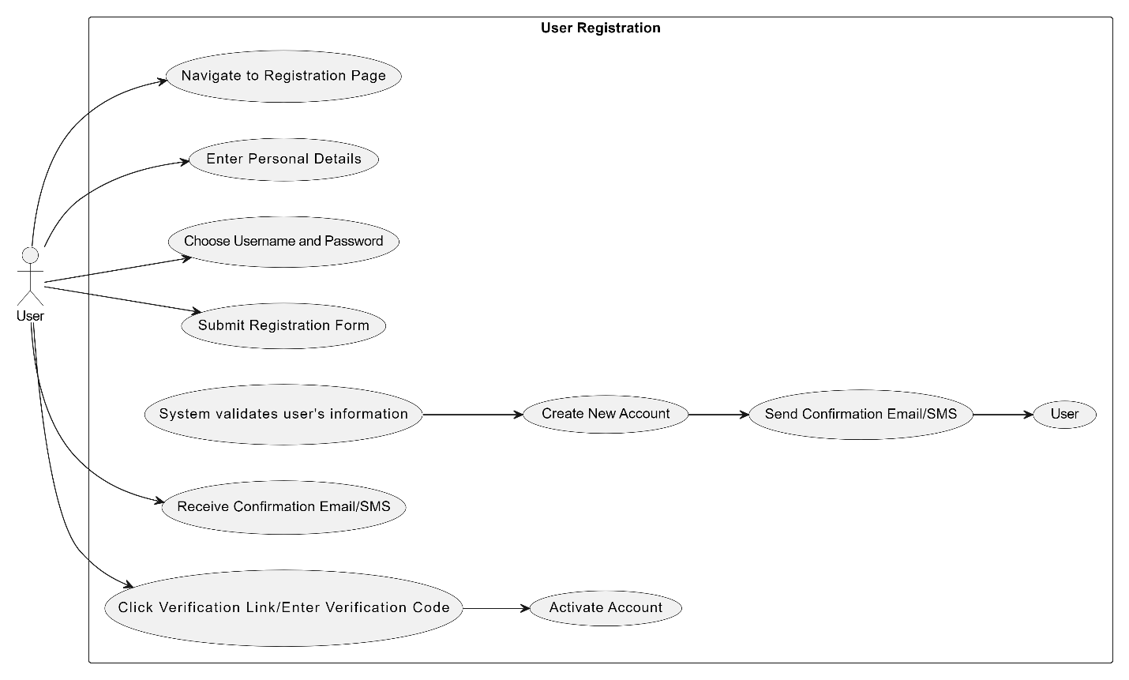

Figure 1 User registration

### Searching for legal Information

Figure 2 Searching for legal Information

### Requesting Legal Consultancy

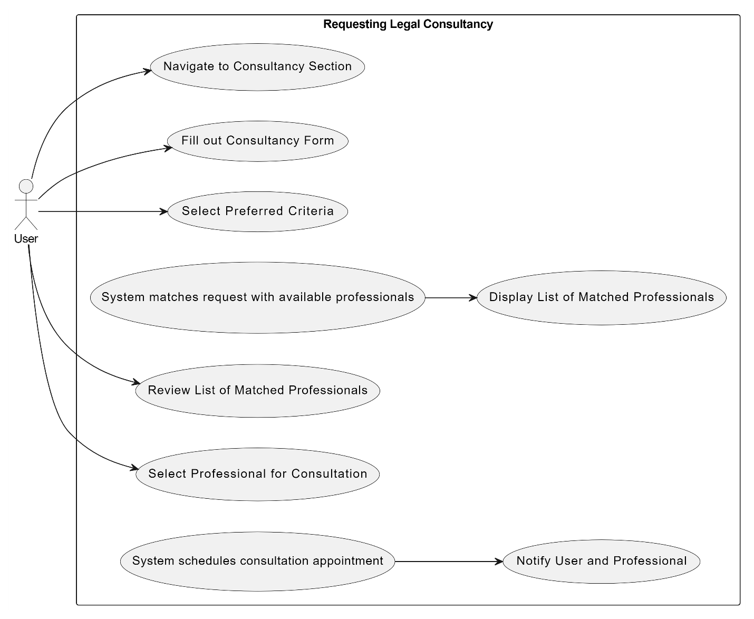

Figure 3 Legal Consultancy

### Managing Appointments

Figure 4 Managing Appointments

­­­

### Legal Information Access

Figure 5 Legal Information Access

### Appointment Scheduling

Figure 6 Appointment Scheduling

### Messaging and communication

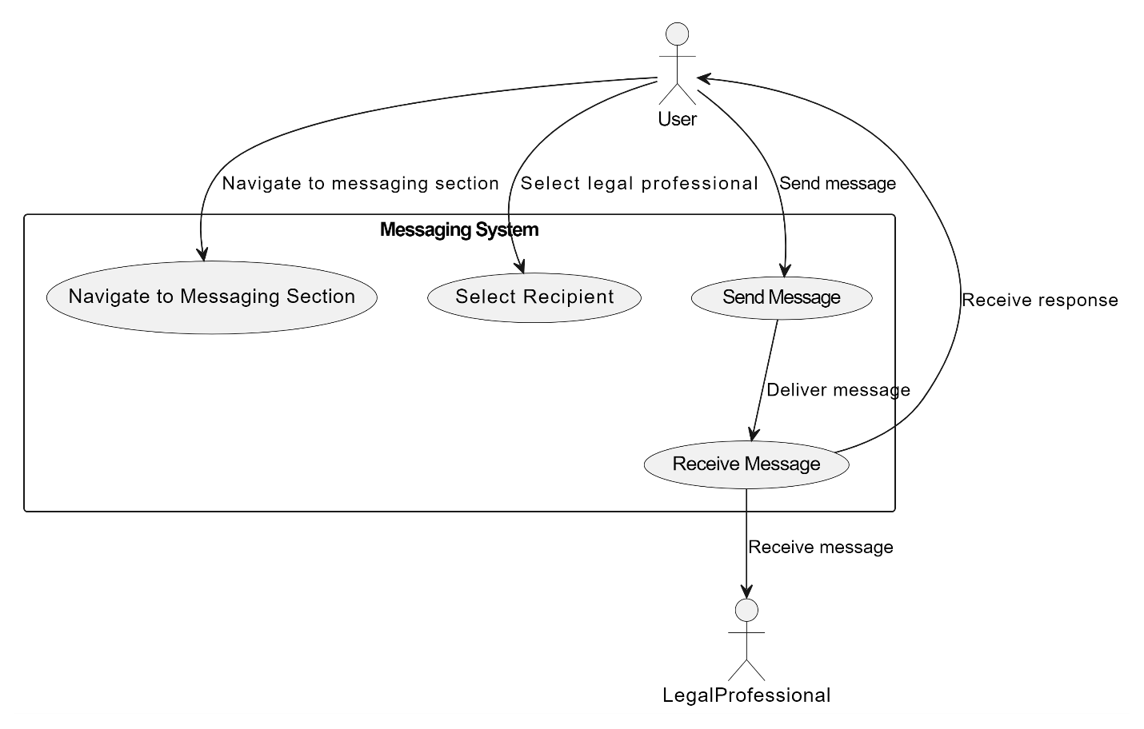

Figure 7 Messaging and communication.

### Legal Case review

Figure 8 Legal Case review

## Software development life cycle model

Agile methodologies, specifically in our case the Scrum, are particularly well-suited for our project. Scrum enables our development team to work concurrently, ensuring efficient progress across various aspects of the platform. Furthermore, testing is integrated seamlessly into the development process, ensuring that quality assurance is an ongoing endeavor rather than a final step.

Scrum's adaptability is paramount for our project, as legal requirements and user preferences may change frequently. By prioritizing tasks based on their importance for each iteration, Scrum allows us to deliver valuable increments of the project consistently, thereby enhancing customer satisfaction and user experience.

Regular meetings with stakeholders, including legal professionals, clients, and administrators, are a cornerstone of our Agile approach. These meetings provide opportunities to clarify requirements, gather feedback, and ensure that the platform aligns closely with the evolving needs of our users.

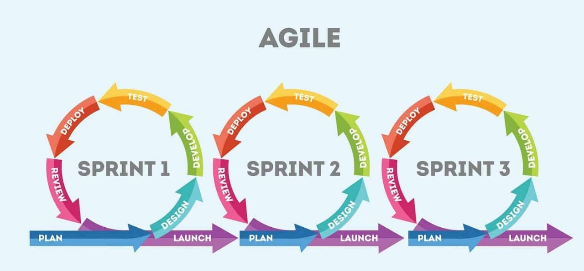

Figure 9 Software Development Life Cycle

# System Design

Our system design will tell us about our architecture and what will be our structure when we step into our development.

## Work Breakdown Structure

The figure shows the work breakdown structure diagram which shows the detailed overview of the development process of application in a sequence. It shows step by step process from analysis to planning to testing.

Figure 10 Work Breakdown Structure

## Activity Diagrams

Here we will describe the activities and their diagrammed representations.

### AD01 - Signup:

The figure shows how users scan be able to sign up on our website by providing correct information leading user to successful account creation.

Figure 11 Activity Diagram (AD)01 - Signup

### AD02 - Login:

The figure shows the activity diagram of the Login feature, user will provide correct email and password to login otherwise error message will be displayed on wrong credentials.

Figure 12 of Login

### AD03 - Forgot Password:

The figure shows the activity diagram of the Forgot Password which describes the workflow of this feature where user first navigate towards forgot password button then by entering correct email and its confirmation, user will be able to reset his/her password.

Figure 13 Forgot Password

### AD04 - Profile Creation:

The figure shows the activity diagram of the Profile Creation where user will first provide the related information in the respective form (either job seeker form or company’s company form) and on successfully provision of complete information, the user profile will be created.

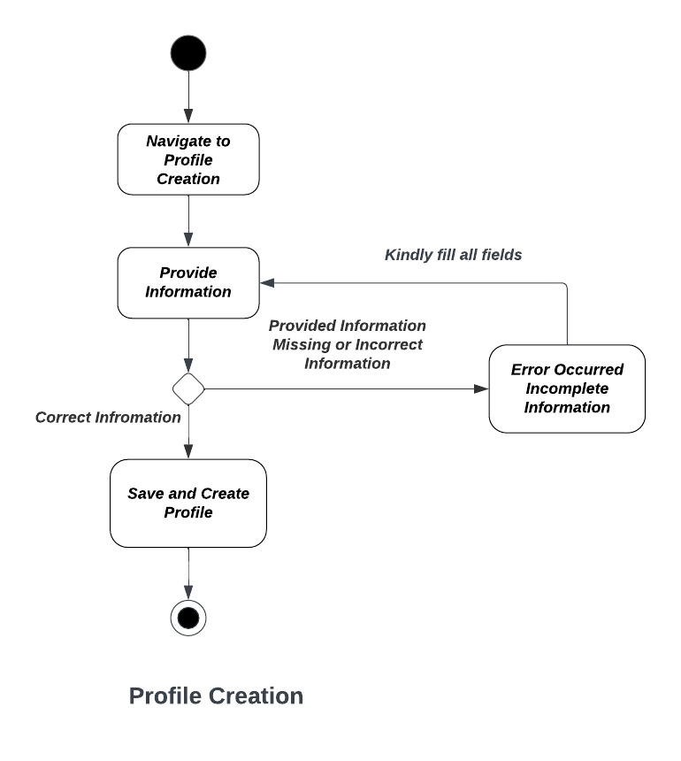

Figure 14 Profile Creation

### Appointment Date Selection

Figure 15 AD04 – Date Selection

### Selecting Legal Professional

Figure 16 AD04 – Selecting Legal Professional

### Managing Case Process

Figure 17 AD04 – Managing Case Process

### Messaging

Figure 18 AD04 – Messaging

## Sequence Diagrams

Following we have all the Sequence Diagrams.

### SD01 – Login

The figure shows the Sequence Diagram of the Login which shows complete steps of Login procedure from user’s filling data fields to the authentication and checking credentials in database.

Figure 19 Sequence Diagram (SD)01 – Login

### SD02 – Signup

The figure shows the Sequence Diagram of the Signup which shows complete steps of Signup procedure from user’s filling data for first signup to the application by filling required fields to the authentication and saving credentials in database.

Figure 20 SD02 - Signup

### SD03 - Profile Creation

The figure shows the Sequence Diagram of the Profile Creation which shows complete steps of Profile Creation procedure from user’s filling data fields to the saving credentials in database and successfully creation of the user profile.

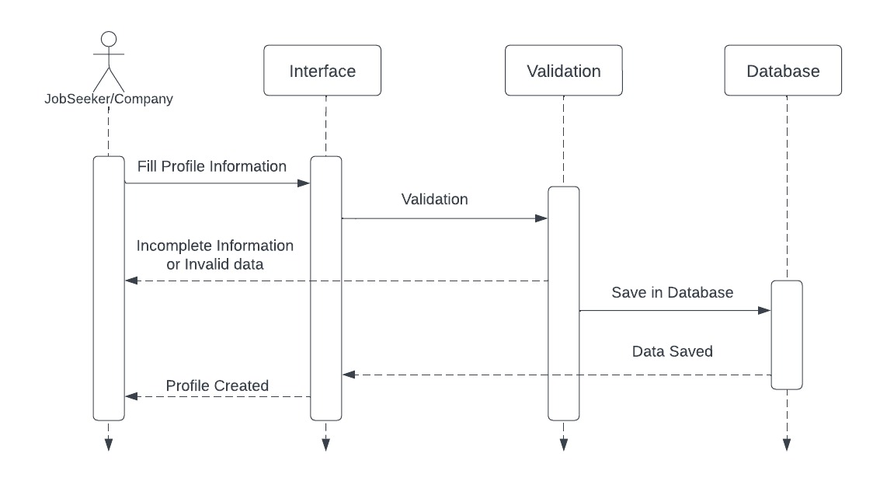

Figure 21 SD03 - Profile Creation

### SD04 - Forgot Password

The figure shows the sequence diagram of Forgot Password which shows the steps for password reset. It begins with the user clicking the password reset button, then the user is validated by backend, sending a reset code and then verifying the code and allow user to reset the password.

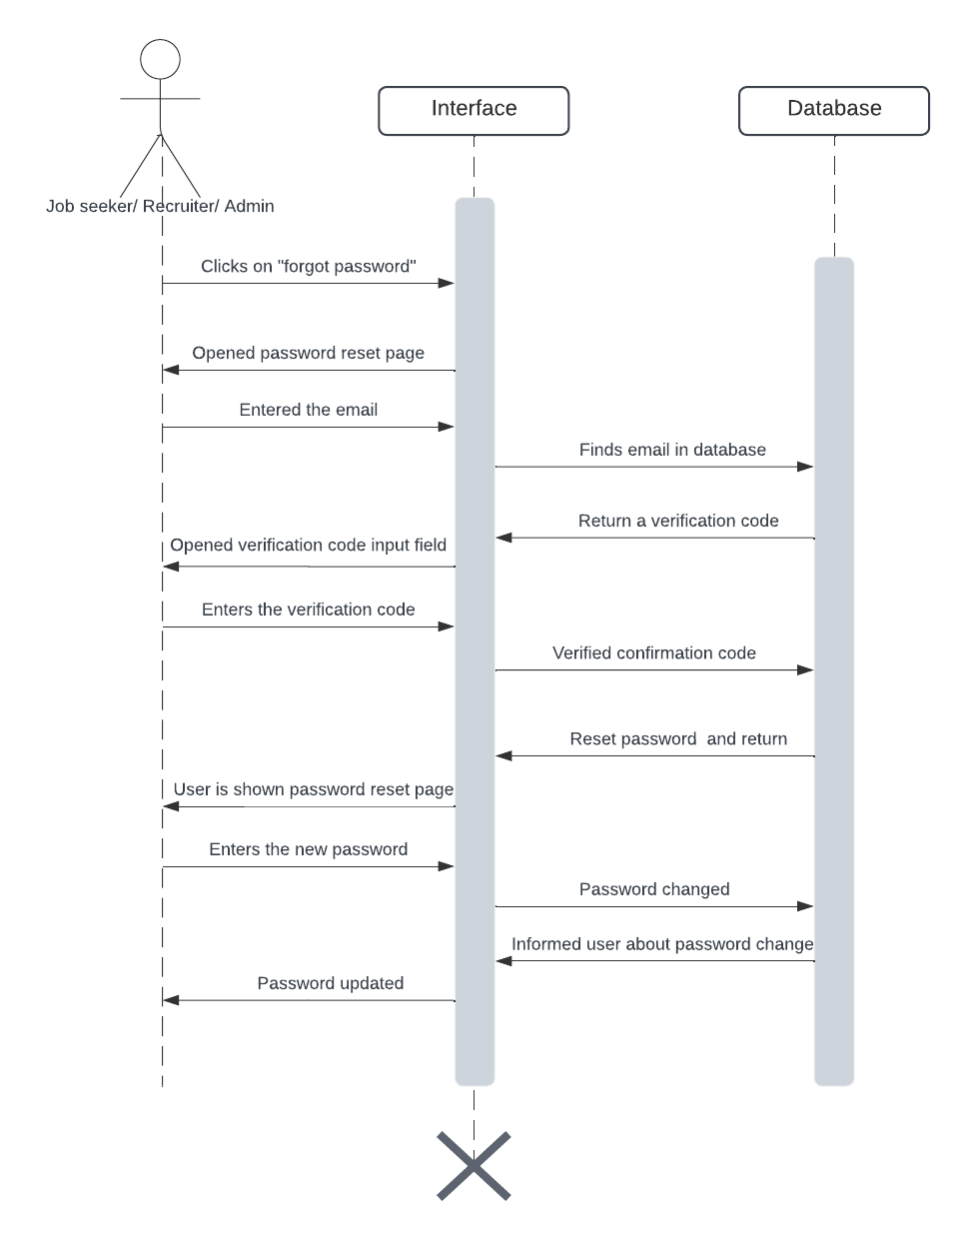

Figure 22 SD04 - Forgot Password

### SD05 - User Support & Complaints

The figure shows the Sequence Diagram of the User Support & Complaints which shows complete steps how admin gets to review users’ complaints & queries through database and perform action like take action & reply them as early as possible.

Figure 23 SD07 - User Support & Complaints

### SD06-Searching for legal Information.

Figure 24 SD06-Searching for legal Information

### SD07- Requesting Legal Consultancy

Figure 25 SD07- Requesting Legal Consultancy

### SD08 - Managing Appointments

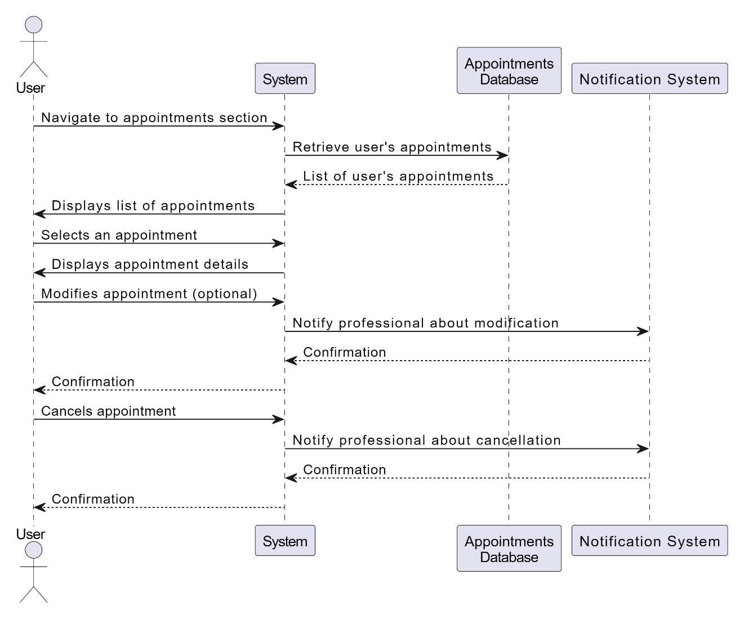

Figure 26 SD08 - Managing Appointments

### SD09 - Legal Information Access

Figure 27 SD09 - Legal Information Access

### SD10 - Appointment Scheduling

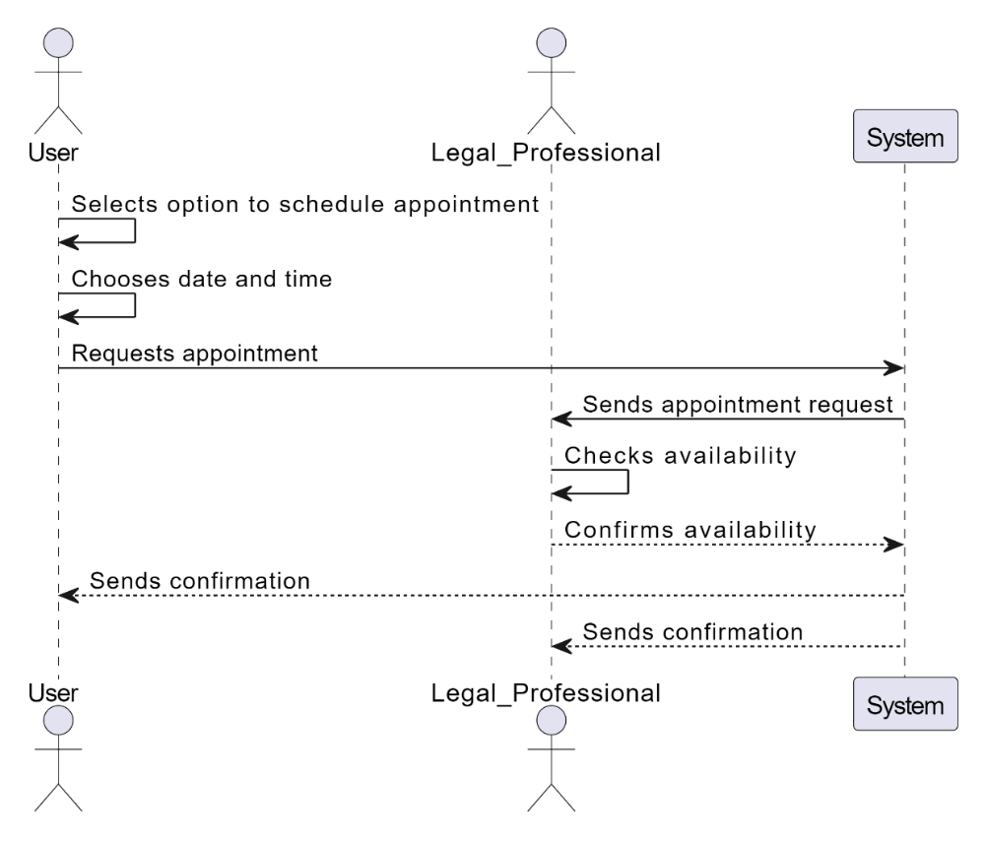

Figure 28 SD10 - Appointment Scheduling

### SD11 - Messaging

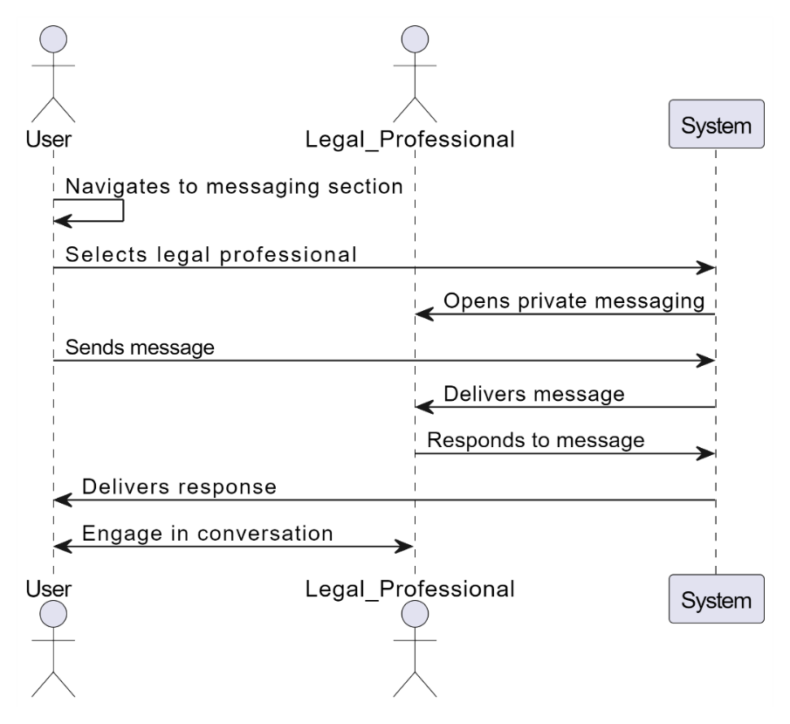

Figure 29 SD11 - Messaging

### SD12 - Legal Case Review

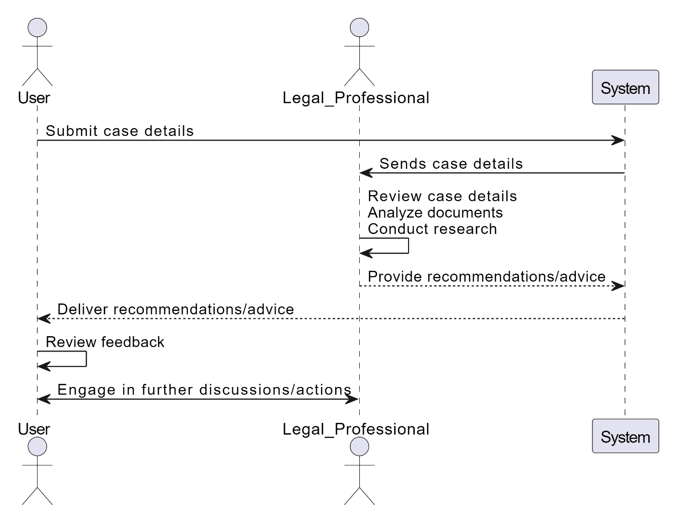

Figure 30 SD12 - Legal Case Review

## Software Architecture

Figure 31 Software Architecture

The software architecture for the "Link-Law.pk" project outlines the structural framework of the web application, delineating its key components and their interactions. At the presentation layer, users interact with the application through web pages and forms, while the application layer orchestrates business logic and processing, utilizing controllers and services to handle user requests. The domain layer in our project encapsulates the core domain logic, it helps our project in defining entities and domain services that model legal consultancy concepts onto our platform. Infrastructure components, in our project provide foundational services such as data access to our clients, external integrations, and also logging on the platform we create. Our database stores persistent data and external systems like our client email servers and payment gateways that will facilitate our communication and functionality extensions in our project. This architecture that we will be using promotes modularity, scalability, and maintainability, ensuring that the project we have "Link-Law.pk" is aligned with stakeholder requirements and quality attributes in our project.

## Class Diagram

Our class diagram that we have created here illustrates the fundamental building blocks of our project that is "Link-Law.pk", this shows us various entities, their attributes, and their relationships between them. We know it serves as a visual blueprint of our system's architecture and functionality, offering us a clear representation of how different components in our site interact and collaborate to fulfil the project's objectives. This comprehensive depiction aids in understanding the organization of data and operations within our system, facilitating effective communication and collaboration among our stakeholders during the development process in our project.

Figure 32 Class Diagram

## Database Diagram

Our database diagram, it depicts that how many collections or table we have there in our database and what are entities of those collections and relationship between them different collections are displayed here.

Figure 33 Database Diagram

## Network Diagram (Gantt chart)

We have created the necessary charts here:

### Gantt Chart

Gantt Chart shows the the activity by each member over the period of FYP. It shows the time an activity take for its completion

Figure 34 Gantt Chart

### Network Diagram

Figure 35 Network Diagram

## Collaboration Diagram

Collaboration Diagrams will give us information us about how our system is collaborating with different features of the website.

### User registration

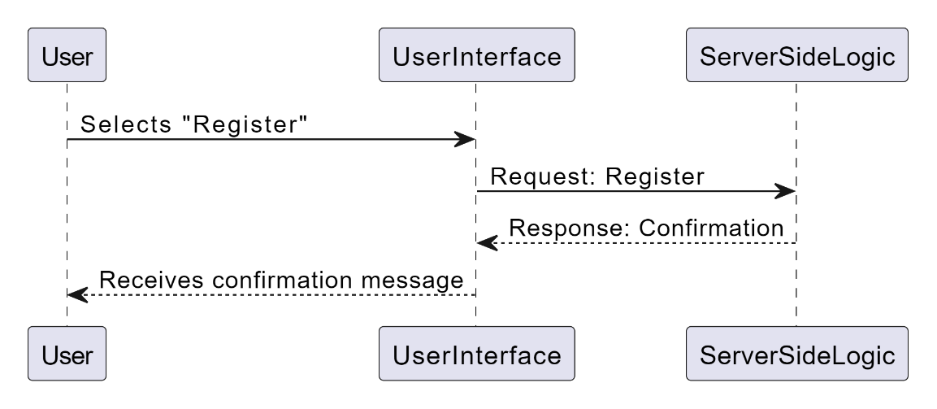

Figure 36 User registration

### Appointment Scheduling

Figure 37 Appointment Scheduling

### Legal Case Management

Figure 38 Legal Case Management

### Messaging

Figure 39 Messaging

# System Testing

In case of system testing, we will be writing different scenario of test cases for our project’s accuracy.

## Test Cases

We have written different test cases for our system.

### TC01 – User Registration

Table 22 TC01 – User Registration

|  |
| --- |
| **Test Case Name:** User Registration |
| **Test Case:**  We need to verify that a new user can successfully register an account with valid credentials.  We need to verify that registration fails with invalid or duplicate email addresses.  We need to verify that our system sends a verification email upon successful registration.  We need to verify that our users cannot access restricted areas of the platform without verifying their email. |
| **Pre-conditions:** The user must have an account on the Link-Law.pk. |
| **Test Steps:**   * Test case starts with the user fills the required fields in the Registration * The user clicks the register button and test case ends. |
| **Expected Result:** The user shall successfully login/sign-up and navigate towards the homepage. |
| **Actual Result:** |
| **Post-conditions:** The user is navigated to the homepage successfully. |
| **Result:** |

### TC02 – Legal Information Access

Table 23 TC02 - Users Information

|  |
| --- |
| **Test Case Name:** Legal Information |
| **Test Case:**  We need to verify that our users can search for legal information using keywords or categories.  We need to verify that search results are accurate and relevant to the user's query.  We need to verify that our users can view and access legal documents, articles, or resources from the search results.  We need to verify that ourusers can filter search results by various criteria such as relevance, date, or category. |
| **Pre-conditions:** The user must have valid credential i.e. email. |
| **Test Steps:**   * The case starts as the user fills out the legal form. * The user hits the signup button and the form is submitted if valid and required data is provided. * The response of account creation is received by the user and test case ends. |
| **Expected Result:** The user legal information successfully gathered. |
| **Actual Result:** |
| **Post-conditions:** The user is navigated to the login page. |
| **Result:** |

### TC03 – Consultancy Request

Table 24 TC03 -Consultancy Request

|  |
| --- |
| **Test Case Name:** Consultancy Request |
| **Test Case:**  We need to verify that our users can submit consultancy requests with detailed information about their legal issue.  We need to verify that our system matches users with available legal professionals based on expertise and availability.  We need to verify that our users receive notifications about matched consultants and consultancy requests.  We need to verify that our legal professionals can accept or decline consultancy requests and communicate with users accordingly. |
| **Pre-conditions:** The user must have account on the Website. |
| **Test Steps:**   * The case starts as the user clicks the consultation option and fills the email and click button. * The user receives the confirmation code and enter the confirmation to verify that valid user is trying to use feature. * After verification of code, user is allowed to consult and after password reset test case ends. |
| **Expected Result:** The use should be able to consult. |
| **Actual Result:** |
| **Post-conditions:** The user can login. |
| **Result:** |

### TC04 - Messaging

Table 25 TC04 -Messaging

|  |
| --- |
| **Test Case Name:** Messaging |
| **Test Case:**  We need to verify that our users can initiate private conversations with legal professionals through messaging.  We need to verify that our users can send messages, attachments, and receive responses from legal professionals.  We need to verify that our messaging history is maintained and accessible for both users and legal professionals.  We need to verify that our users receive notifications for new messages and replies. |
| **Pre-conditions:** The user is logged in on Link-Law.pk and wants to Communicate. |
| **Test Steps:**   * The case starts as sender. * The user hits the send button after filling the required fields. * The response of sent message is received by the user and test case ends. |
| **Expected Result:** Receiving and sending of messages. |
| **Actual Result:** |
| **Post-conditions:** The user will be able to see the message in the chat list. |
| **Result:** |

### Appointment Scheduling

Table 26 TC05 - Appointment Scheduling

|  |
| --- |
| **Test Case Name:** Appointment Scheduling |
| **Test Case:**  We need to verify that our users can schedule appointments with legal professionals for consultation.  We need to verify that our users can view available time slots and select preferred dates and times for appointments.  We need to verify that our users receive confirmation notifications for scheduled appointments.  We need to verify that our legal professionals can manage their availability and accept or reject appointment requests. |
| **Pre-conditions:** The person is logged in on Link-Law.pk and wants to Schedule appointments |
| **Test Steps:**   * The case starts as the company is redirected to the profile creation form after successful login for first time. * The company fill out the required fields and submit form, if valid and required data is provided then form is submitted. * The response of profile creation is received by the company and test case ends. |
| **Expected Result:** The profile shall be created successfully and the company can preview the profile. |
| **Actual Result:** |
| **Post-conditions:** The person profile is created is able to perform further actions. |
| **Result:** |

### Legal Case review

Table 27 TC06 - Legal Case

|  |
| --- |
| **Test Case Name:** Legal Case Review |
| **Test Case:**  We verify that our users can submit details of their legal cases for review by legal professionals.  We must also verify that legal professionals on our site can access case details, documents, and relevant information provided by users on our platform Law-Link.pk.  We verify that our legal professionals can also review their cases, analyze their documents, and provide recommendations or advice to their clients. |
| **Pre-conditions:** The user is logged in on platform. |
| **Test Steps:**   * The case starts as the user is looking at cases. * The user is asking for review as advertised. |
| **Expected Result:** User get the required review. |
| **Actual Result:** |
| **Post-conditions:** The User should get the necessary information. |
| **Result:** |

### Security control

Table 28 TC07 – Security control

|  |
| --- |
| **Test Case Name:** Security Control |
| **Test Case:**  The very first step of our verification is that our user authentication and authorization mechanisms are in place and functioning correctly for our site. Along with that we will also verify that our users can access only the functionalities and resources they are authorized to use and in this way our platform will stay secure and safe. |
| **Pre-conditions:** The user is logged in on platform. |
| **Test Steps:**   * The case starts as the user opens the platform by logging. * The test case ends with end-to-end encryption. |
| **Expected Result:** End to end Encryption. |
| **Actual Result:** |
| **Post-conditions:** The User security is ensured. |
| **Result:** |

### Performance and Scalability

Table 29 TC08 - Performance and Scalability

|  |
| --- |
| **Test Case Name:** Performance and Scalability |
| **Test Case:**  We have to make sure that our system responds within acceptable response times for user interactions and requests and it also can handle concurrent user sessions and requests without significant degradation in the performance of our site.  Moving ahead to the next step of our verification is that our platform can scale horizontally to accommodate increasing user traffic and data volume. |
| **Pre-conditions:** The user is logged in on Link-Law.pk. |
| **Test Steps:**   * We start this particular case with the assumption that the platform can scale horizontally to accommodate increasing user traffic and data volume that we will be gathering. |
| **Expected Result: Scalability.** |
| **Actual Result:** |
| **Post-conditions: User login** |
| **Result:** |

## Unit Testing

In unit testing we are testing different fragments of our system and see how different modules respond to our defined test cases

### User Authentication Module

* For the sake of user verification, we need that our user can register with valid credentials on our site.

### Legal Information Retrieval Module

* Now if we want to verify that our users can search for legal information using keywords using our site.

### Consultancy Request Module

* To consult the request of the user we need to verify that our users can submit their consultancy requests with valid details.

### Appointment Scheduling Module

* We need to verify that our users can schedule their appointments with legal professionals on our platform.

### Messaging and Communication Module

* We need to verify that our users can send messages to their legal professionals.
* We need to verify that our legal professionals receive messages from our users.

### Legal Case Review Module

* We need to verify that our users can submit their details of legal cases for which they want a review.

### Security Module

* We need to verify that our user authentication and our site’s authorization mechanisms are functioning correctly to facilitate our users.
* We need to verify that sensitive user data is securely stored and protected and it is encrypted.

### Error Handling Module

* We make sure verify that our appropriate error messages are displayed for invalid user inputs and they are handled.

### Performance Module

* We stand by the fact and verify that our system response times meet acceptable performance benchmarks.

## Integration testing

When we integrate two modules, we have to design tests for that purpose too.

### User Authentication and Registration Integration

* We need to verify that our user registration integrates correctly with our authentication module, allowing our registered users to log in with their credentials.

### Legal Information Retrieval Integration

* We need to verify that our legal information retrieval module integrates with our search functionality, allowing our users to search for legal documents and articles based on their keywords or categories that they need.

### Consultancy Request and Appointment Scheduling Integration

* We need to verify that our consultancy request module integrates with our appointment scheduling, allowing all the users we have to schedule appointments with legal professionals on Link-Law.pk after submitting their consultancy requests.

### Messaging and Communication Integration

* We need to make sure that our messaging module integrates with our user authentication and our consultancy request modules, allowing all of our users to communicate with legal professionals after submitting their consultancy requests.

### Legal Case Review Integration

* We need to verify that our legal case review module integrates with our user authentication and consultancy request modules, allowing our users to request legal professionals to review their legal cases.

### Security and Error Handling Integration:

* We need to verify that our security mechanisms, such as user authentication and authorization, integrate correctly with all our modules to prevent unauthorized access to sensitive functionalities and data of our users.

### Performance Integration

* We must ensure that our integrated system meets acceptable performance benchmarks for response times and scalability under various user loads at all times.

## Acceptance Testing

To see that modules have been correctly integrated and have accepted the new parameters, we design acceptance testing.

### User Registration and Authentication

* We ensure that a new user successfully registers an account on the platform.

### Legal Information Access

* We make sure that our users can search for specific legal information using keywords or categories.

### Consultancy Request and Appointment Scheduling

* The prime goal we have is that users can submit consultancy requests with detailed information about their legal issue.

### Messaging and Communication

* What we want foremost is that our users to be able to communicate with legal professionals through private messaging within the platform.

### Legal Case Review

* We have the responsibility to make sure that our users can submit details of their legal cases for review by legal professionals present on the platform.

### Security and Access Control

* We need to make sure that the user authentication and authorization mechanisms are functioning correctly.

### Performance and Scalability

* Our responsibility is that our system response times meet acceptable performance benchmarks.

### Error Handling and Recovery

* We will display appropriate error messages are displayed for invalid user inputs or system errors.

### Compatibility and Integration

* We are working under assumption that our platform is compatible with different web browsers and devices.

# Conclusion

### Problems Faced

We would like to conclude our project "Link-Law.pk," by mentioning that our team had several challenges along our journey, but we resolved all the conflicts as a team. I would like to mention that these challenges ranged from technical hurdles such as integrating complex functionalities into our platform to resource constraints like limited manpower or time constraints that we have mentioned in our project.

Additionally, we were also faced with many communication issues, such as misalignment of our expectations between us and our stakeholders or there were some unclear requirements along the way too, which also posted significant obstacles in our way. As we have overcame these challenges, they demanded careful problem-solving from our end, collaboration among us which includes the team members, and our adaptability to changing circumstances along the way.

### Lessons Learned

If we talk more about the challenges that were encountered by our team during the project, we have gained very important insights as we experienced each of the mentioned phases in our project.

And each of these phases contributed to our team's learning and growth. For us this became apparent that clear communication between all of our channels and regular stakeholder engagement will be crucial for ensuring our project’s success and the progress of our platform.

We have to mention, the problems we faced also guided us in prioritizing tasks based on their impact and feasibility helped us a lot in managing resource constraints effectively in our endeavor.

We like to conclude this with the approach that, we were embracing an iterative approach to development allowed us the flexibility in accommodating changing requirements at any point in our journey as such a case appeared in front of us and we continued in refining of our features based on our user feedback given. Overall, we can say that the project provided a wealth of learning opportunities for us, that can be applied to future endeavors.

## Project Summary

The "Link-Law.pk" project that we have developed aimed to create a comprehensive web platform for legal consultancy services in our country, providing our users with access to legal professionals and resources of our site. Key features included in our platform were user registration and authentication, appointment scheduling, case management, messaging functionality, and a repository of legal information. Technologies that we will or have used such as HTML, CSS, JavaScript, PHP, and MySQL were utilized by us to develop the platform, which culminated in a user-friendly and scalable solution in platform we have developed.

## Future Work

As we look ahead, there are several areas for us that have the potential enhancement and develop the "Link-Law.pk" platform into a different more engaging site for our users. We have to make sure the optimization of performance and scalability improvements will be essential to accommodate a growing user base and also help our current users. Additionally, we need to be exploring opportunities for mobile application development or we have to be expanding the platform's reach through marketing initiatives could further enhance its impact and relevance in the legal consultancy domain.

# References

1. The World Justice Project - Pakistan:

<https://worldjusticeproject.org/rule-of-law-index/country/Pakistan>

1. Law and Society Trust - Pakistan:

Law and Society Trust. (n.d.). Careers. <https://www.lstlanka.org/careers/>

1. Avvo:

Avvo. (n.d.). Find a Lawyer.

<https://www.avvo.com/find-a-lawyer>

1. LegalZoom: LegalZoom. (n.d.).

<https://www.legalzoom.com/>

1. Rocket Lawyer:

Rocket Lawyer. (n.d.). <https://www.rocketlawyer.com/>

1. Punjab Legal Aid Cell (PLAC):

Punjab Legal Aid Cell. (n.d.). Punjab Legal Aid Agency. <https://ppd.punjab.gov.pk/punjab-legal-aid-agency>

1. Sindh Legal Advisory Call Center (SLACC):

Catchpoint. (n.d.). Benefits of IPv6. <https://www.catchpoint.com/benefits-of-ipv6/slaac-ipv6>

1. "Designing Effective Online Legal Service Platforms:

A User-Centered Approach" by Richard Susskind and Alexandra Jagger:

Susskind, R., & Jagger, A. (n.d.). Designing Effective Online Legal Service Platforms: A User-Centered Approach. The Law Society. <https://www.lawsociety.org.uk/en/topics/blogs/the-power-of-a-well-designed-website>

1. "User Experience (UX) Design for Legal Websites and Applications" by Nielsen Norman Group:

Nielsen Norman Group. (n.d.). Definition of User Experience. <https://www.nngroup.com/articles/definition-user-experience/>

1. "Data Protection Law in Pakistan":

Dawn. (n.d.). Data Protection Law in Pakistan. <https://www.dawn.com/news/1767502>

1. "Pakistan Bar Council - Code of Ethics for Lawyers":

Pakistan Code. (n.d.). Pakistan Bar Council - Code of Ethics for Lawyers. <https://pakistancode.gov.pk/pdffiles/administrator006d8e1bfde45871ddef6937f29fa>

1. Article:

"Legal Aid in Pakistan: Challenges and Opportunities" by The Law & Development Review (2012): UNDP Pakistan. (2012). Legal Aid in Pakistan: Challenges and Opportunities. <https://www.undp.org/pakistan/press-releases/legal-aid-and-justice-authority-european-union-and-undp-hold-consultative-workshop-enhance-access-legal-aid-pakistan>

1. Article: "The Rise of Online Legal Services: A New Era for Legal Aid?" by American Bar Association (2017):

American Bar Association. (2017). The Rise of Online Legal Services:

A New Era for Legal Aid? [https://www.americanbar.org/groups/bar leadership/resources/resourcepages/future/](https://www.americanbar.org/groups/bar%20leadership/resources/resourcepages/future/)

1. USA Law directory

<https://www.lexinter.net/>

1. Pakistan lawyer directory:

<https://pk.pathlegal.com/>

1. Report:

"The Future of Legal Services: 2020 and Beyond" by Thomson Reuters (2020): Thomson Reuters. (2020). The Future of Legal Services: 2020 and Beyond. <https://legal.thomsonreuters.com/en/insights>